# Setting Up Guide

## Downloading Elasticsearch

1. Check if have at least Java 8 installed in your machine.

To check, in your command prompt:

***java –version***

1. If yes, that’s fine. Else, install Java and set java bin in your system’s path.

Java Download:

<https://www.oracle.com/technetwork/java/javase/downloads/jdk11-downloads-5066655.html>

For Reference:

* MAC: <https://www.youtube.com/watch?v=y6szNJ4rMZ0>
* Windows: <https://www.youtube.com/watch?v=vNmrtyAZZvc>, <https://www.mkyong.com/java/how-to-set-java_home-on-windows-10/>
* Linux: <https://www.youtube.com/watch?v=zAiwUUEjFCI>

1. After Java is available in your machine, download Elasticsearch and extract it in your preferred location: <https://www.elastic.co/downloads/elasticsearch>
2. From command line/terminal, go to the **elasticsearch bin folder** and then **run elasticsearch**.

For Reference:

* Windows:

cd to the path where elasticsearch is installed

then hit, bin\elasticsearch.bat

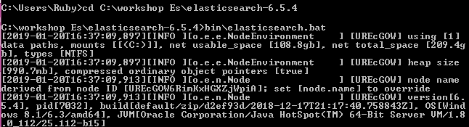

* Linux/Mac:

cd to the folder where elasticsearch is installed

then hit, bin/elasticsearch

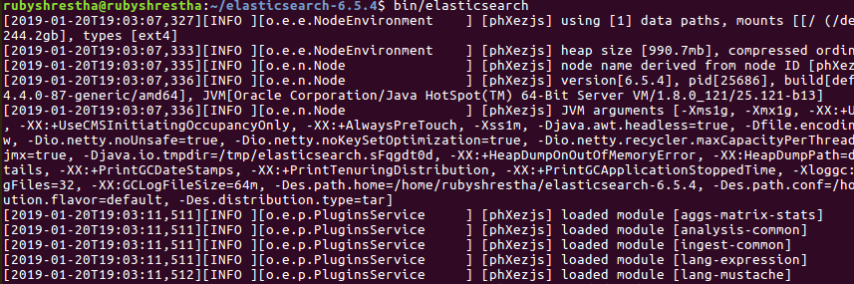

1. After this is done, open any http client. Open any browser for an instance and enter:

[http://localhost:9200](http://localhost:9200/)

Elasticsearch runs on http port 9200 by default.

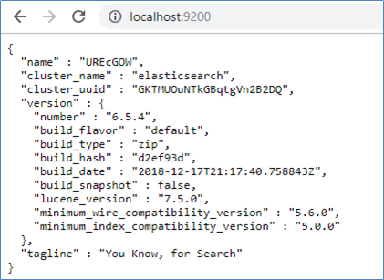

This means your Elasticsearch is up and running now!

## Downloading Kibana

1. Go to the download page: <https://www.elastic.co/downloads/kibana>
2. Download as per your operating system (Windows/Mac/Linux/...)
3. Extract to the desired location.
4. Open cmd or terminal.
5. cd inside the kibana folder
6. then hit,
   1. Windows: bin\kibana
   2. Linux/Mac: bin/kibana
7. Kibana will run then take some time to run.
8. It will run in port 5601
9. To check if it has been run, go to browser: localhost:5601, the following view should appear.

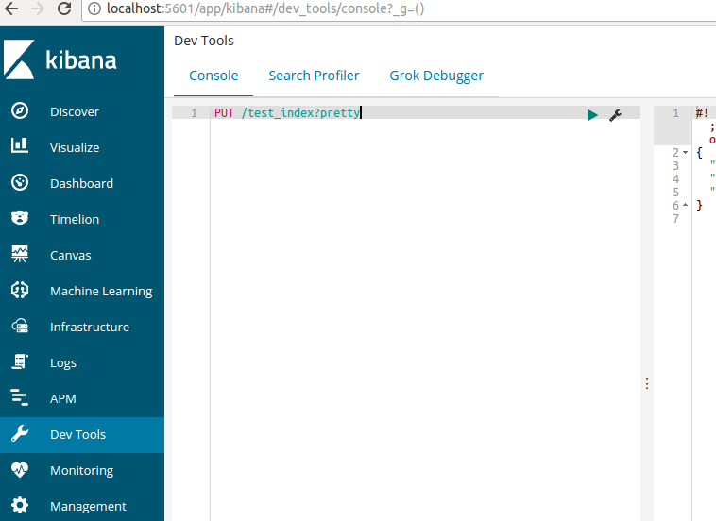

Of the many functionalities, we will be focusing only on Dev Tools (as our REST Client) for learning Elasticsearch during this workshop.

## Extra

* Install JSON Viewer Chrome Extension for proper JSON viewing in Chrome Browser.

<https://chrome.google.com/webstore/detail/json-viewer/gbmdgpbipfallnflgajpaliibnhdgobh>

* Downloading cURL (for windows)

Download from: <https://curl.haxx.se/windows/>

Unpack in your desired location

Add the path to its bin folder in the System Path variable

* Downloading cURL (for linux): sudo apt-get install curl

# Introductory Information

Apache Lucene is an information retrieval software library which you can import into your Java project and call functions of for performing information retrieval. However, using it is technically challenging. So, in order to ease the use of Apache Lucene, Elasticsearch was developed. Elasticsearch (ES) is based on Apache Lucene and provides us a convenient way to utilize the benefits of Apache Lucene. ES is a search engine/server which allows us to perform search functionalities with Apache Lucene via simple JSON Based REST API and related commands/syntax.

Elasticsearch is open source with its codes available in<https://github.com/elastic/elasticsearch>. We can see its codes available under directories: modules (default ES features), plugins (extra ES features as per user requests), and server (all modules and plugins). Contributing to ES features (adding or updating features) however requires knowledge of Apache Lucene. Just letting you guys know that there are areas of exploration if you want to explore. The aim of this workshop, however, is not to teach to write java codes for ES features but to guide to use ES as a search and analysis engine. So, we can keep the java codes aside for a while.